Ref - Paliwal PK, Sirohiwal BL, Sharma L, Chawla H, Khanna K. Shoe, Sock And Bullet- An Imbroglio In A Case Of Firearm Wound On Rare Site. Anil Aggrawal's Internet Journal of Forensic Medicine and Toxicology [serial online], 2013; Vol. 14, No. 1 (Jan - June 2013): [about 6 p]. Available from: https://anilaggrawal.com/ij/vol_014_no_001/papers/paper006.html. Published: Jan 1, 2013.

Access the journal at - http://anilaggrawal.com
******************************

SHOE, SOCK AND BULLET- AN IMBROGLIO IN A CASE OF FIREARM WOUND ON RARE SITE

*Dr. P. K. Paliwal
**Dr. Basant Lal Sirohiwal
***Dr. Luv Sharma
****Dr. Hitesh Chawla
***** Dr. Kunal Khanna

Corresponding authors
*Senior Professor, Dept of Forensic Medicine, Pt. BD Sharma, University of Health Sciences, Postgraduate Institute of Medical Sciences, Rohtak, Haryana 124001;
Email- drpramodpaliwal@gmail.com
** Professor, Dept of Forensic Medicine, Pt. BD Sharma, University of Health Sciences, Postgraduate Institute of Medical Sciences, Rohtak, Haryana 124001;
Email- drbasantsri@gmail.com
*** Professor, Dept of Forensic Medicine, Pt. BD Sharma, University of Health Sciences, Postgraduate Institute of Medical Sciences, Rohtak, Haryana 124001.
**** Assistant Professor, Dept of Forensic Medicine and Toxicology, SHKM Govt. Medical College Nalhar, Mewat, Haryana;
***** Resident, Dept of Forensic Medicine, Pt. BD Sharma, University of Health Sciences, Postgraduate Institute of Medical Sciences, Rohtak, Haryana 124001

Abstract: - Usually, there is hardly any doubt while examining a typical injury of firearm discharge, but the medical officer is in imbroglio in an atypical firearm wound to give opinion regarding the kind of weapon, direction and range of firearm etc.; and particularly when it is situated on an unusual unexplainable atypical site, without reconstructing the same. We were confronted with a through and through punctured wound on the sole alleged to have been caused during firearm discharge from a distant range; and shoe, sock and bullet were recovered from the spot depicting confusing findings.
A case was referred for expert opinion from Accident & Emergency Department, Postgraduate Institute of Medical Sciences, Rohtak, Haryana, India with the alleged history of firearm injury on left foot. The medical officer, at primary health centre after examination, kept it pending with big question mark on the kind of weapon.
Key words: perforation of sole, socks, bullet, firearm wound, gunpowder remnant
Brief history: A young adult male, while relaxing and sitting in the chair and resting his legs on the cot in partially extended posture with the front medial part of his shoe dangling on his left foot, in front of his house on one late evening of august of 2011; he got into an argument with one of his distant relative on some property dispute and then that relative pointed a gun towards him. On standing up and as soon as he started walking, he felt sudden pain in the left foot along with numbness like sensation. Then he realized something had hit his left foot which was bleeding profusely.
He was taken to primary health center where medical officer on examination noted two lacerated wounds, one on medial aspect and one on lateral aspect of left foot, but he was not very sure whether this injury was due to firearm or not and was in enigma to give opinion regarding the kind of weapon and nature of injury so the patient was referred to higher center for Forensic Expert opinion for kind of weapon and nature of this injury.
Observations
On examination the vitals were normal and the person was feeling some difficulty on walking in the left foot that was bandaged. On removal of the bandage of left foot one perforated wound was found on its sole (fig-1a, 1b, 1c) with the details as under:
- A punctured wound (1×0.5 cm) over medial border of left foot, 8cms above the base of great toe. The margins of wound were irregular and somewhat inverted, with skin flap on sole side. The blood like strains were present on the sole going towards the heel side;
- A crescent shaped punctured wound (1×0.5 cm) situated on lateral border of sole of left foot, 2.5 cm above the base of 5th toe. The margins of wound were irregular, somewhat everted and contused all around more so on the inner aspect. The convexity of the crescent was on the outer aspect.
The area of sole (2.5x7.5cms) connecting these wounds was raised tender palpable with prominent bluish margins on both sides thus the extent, configuration, design and outlook of the cavity of perforation indicating the track of wounds in the underneath tissues of sole probably due to firearm injury. There was no diagnostic evidence of firearm discharge appreciated around the wounds like singeing, blacking, tattooing and abraded / contused collar. The area around the wounds were mopped with gauge piece; and preserved &sent for ballistic analysis.
On radiological examination, no bony injury was appreciated.
The shoe and socks worn by the patient at the time of assault were preserved by the Medical Officer at the time of initial medico-legal examination that had also been brought by the Investigating Officer for observations.
Examination of shoe and socks:
- The shoe was black firm leathery without laces having pool of dry blood like stains on outer middle aspect of inside sole region. The area of the shoe on the inner aspect of upper was showing a hole with fibers positioning outwards.(fig-2)
- The examination of sock revealed two holes in the inner and outer aspect of sole area with dry blood like stains over them.(fig-3a & 3b)
The Investigating officer also brought a revolver alleged to have been used by the assailant and a deformed bullet along with used cartridges recovered from the scene of crime (fig-4). We opined that the wound might have been caused by rifled firearm ammunition discharged from a distant range as alleged by the victim, however, for the confirmation of kind of weapon, the shoe, socks and the gauge pieces mopped from the wound margins were preserved and sent for ballistic examination.
Opinion of ballistics expert: - the accredited forensic science laboratory revealed that the holes on the shoe and socks were caused by lead bullet projectile; nitrate was detected in the swab taken from and around the wound number one and no gunshot residue was detected from the swab from the wound number two. The revolver was found in working order and the cartridge case has been fired from this revolver and not from any other firearm even of the same make and bore calibre because every firearm has its own individual characteristic marks. The blood stains on the shoe, socks and the specimen of the injured were found to be matching to each other.
Reconstruction of the scene:
All the findings (supra) while taken in to consideration, for reconstruction of scene of crime in this instant case of being atypical site of firearm injury i.e. sole, a single hole with outward projecting fibres in the leather shoe suggesting exit without any entry wound in the shoe, two holes in the socks and perforating wound on the sole of the victim in demarcated oblique straight path without any diagnostic findings of rifled firearm ammunition and a bullet alleged to have been recovered from the scene by the police. these appears to be inconsistent to each other but appears to be consistent with the history given by the victim to the effect that while he was sitting on a chair and relaxing his leg on a cot in a partially extended position with his shoe partially in situ in his foot the firearm might have been discharged at him from distant range in a direction from inwards, outwards and forwards from wound one to two after perforating the shoe and socks came out and fall in the partially in situ shoe dangled in foot without making a exit in it.
Problem in reconstruction
While pronouncing the reconstruction of the mechanism of production of this injury as alleged to be a case of firearm, we confronted with a number of contradictory findings. First contradictory funding was that the shoe being the outermost covering of the sole and foot should have two holes in the form of entry and exit sites rather than one hole that too on inner aspect with outward tags indicating it to be an exit wound only; second was the characteristic of wounds without any grossly appreciable effect of residue of gunpowder discharge or the effect of bullet around the entry wound, so it is difficult to give opinion about the entry and exit wounds. It became more important and attentive when there was counter allegations about the fabrication of injuries in this part of country and keeping in view the direction of courts in other such injury cases. But the ballistic opinions (supra) sort out the problem about the kind of weapon used and as such collaborate the history given by the patient. On the other hand even when the findings are contradictory and bullet is recovered from the body after tracing a complicated course within the body came to lodge in the head of the femur ¹ then there is no problem in registering the opinion.

Discussion
Before we can explain the production of the firearm injury particularly herein of the rifled firearm ammunition, it would be worth to understand the concept of it. The concept held by most individuals, that the bullet goes through a person like a drill bit through wood, “drilling” a neat hole through structures that it passes through. However, this concept is erroneous. As a bullet moves through the body, it imparts kinetic energy to the surrounding tissues, flinging it away from the bullets path in a radial manner (direction) and producing a temporary cavity considerably larger than the diameter of the bullet. The size and the shape of their temporary cavity depend upon the amount of kinetic energy lost by the bullet in its path through the tissues, how rapidly the energy is lost, and the elasticity and cohesiveness of the tissue. The size of both the temporary and permanent cavities is determined not only by the amount of kinetic energy deposited in the tissue but also by the density and elastic cohesiveness of the tissue. The bullet will began to expand shortly after entering the body, with a resultant rapid loss of kinetic energy. A large temporary cavity is formed immediately as the bullet enters the body. Out of the various characteristics that determined the amount of kinetic energy lost by a bullet, one is the density, strength, and elasticity of the tissue struck by a bullet as well as the length of the wound track. The denser the tissue the bullet passes through, the greater the retardation and the greater the loss of the kinetic energy. Increased the density acts to increase the yaw as well as shortening the period of gyration. This increased angle of yaw and the shortened period of gyration lead to greater retardation and increased loss of kinetic energy. ²
Rifled firearm wounds are usually recognized without any difficulty with their characters like singeing, blackening, tattooing, abraded / contused / grease collar, conditions of the margins and so on. Abraded / contused / greased collar, being diagnostic evidence of distant range, may sometimes be absent, if tissues are soft and yielding involved from a distant range. However, the general concept of wound produced by rifled firearm ammunition is that it may simulate a wound inflicted by red hot pocker/ burning pointed stick and the same has to be differentiated.³ sometimes the injuries produced by the projectiles discharged from firearms may present the characteristics of lacerated wounds.⁴ In the present case the extent, configuration, design and outlook of the cavity of the perforation in the form of a plastic water pipe on one of the thickest part of the skin of sole gives indication of its production by a discharge of a rifled firearm weapon from a distant range and not otherwise.
The severity and extent of a firearm wound is determined not by the amount of kinetic energy possessed by a bullet but rather by the amount of this energy that is lost in the tissue. The major determinants of the amount of kinetic energy lost by a bullet in the body are (1) the kinetic energy possessed by the bullet at the time of impact with the body, (2) the shape of the bullet, (3) the angle of the yaw at the time of impact, (4) any change in the presented area of the bullet in its passage through the body, (5) construction of the bullet, and (6) the biological characteristics of the tissues through which the bullet passes.²
Conclusion:
The above observations clearly illustrates that when a case of alleged firearm injury without typical findings and on rare site is examined then not only the extent, configuration, design and outlook of the cavity of perforation should be taken into consideration while pronouncing the opinion but also the ballistic analysis including examination of the clothing / wearing of injured person along with mop ups of the surrounding area of the wounds that may also contain diagnostic findings to help in framing final opinion.
References:
- http://www.anilaggrawal.com/ij/vol_009_no_001/papers/paper004.html (retrieved on 11.09.2012)
- Di Maio VJM. Gunshot wounds- Practical aspects of firearms, ballistics and forensic techniques. Elsevier: New York; 1985First edition. P.41-4.
- Reddy KSN. The Essentials of Forensic Medicine and Toxicology. 30th ed. Om Sai Graphics: Hyderabad; 2011.p.197, 205.
- Mathiharan K, Kannan K. Modi A Text Book of Medical Jurisprudence and Toxicology. 24th ed. Lexis Nexis Butterworths Wadhwa:Nagpur;2012.p. 537

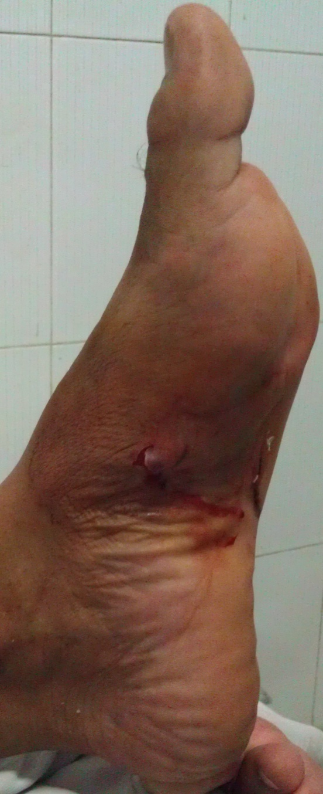
Fig. 1a

A punctured wound with irregular margins situated over medial border of left foot with convexity on sole side. The dry blood like strains on sole going towards the heel side (fig-1a)

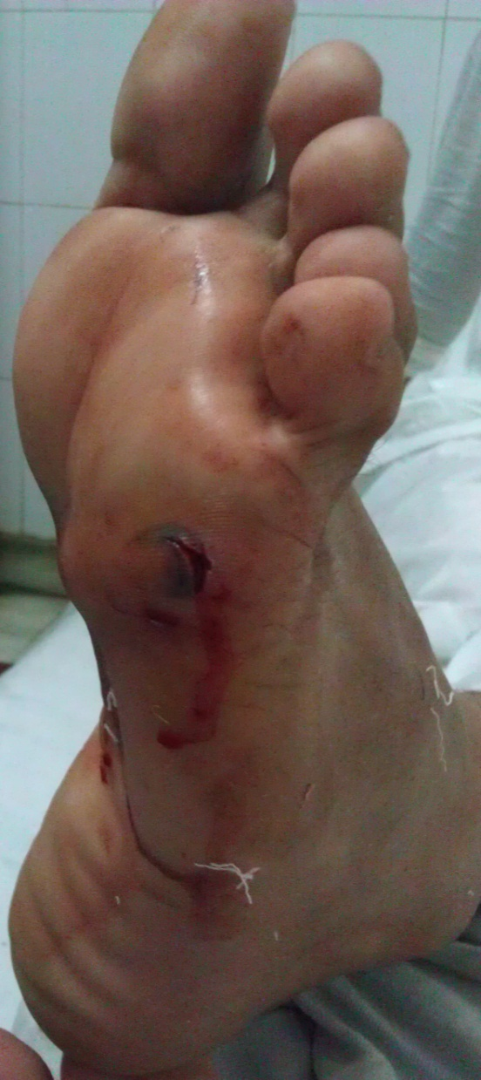
Fig-1b

A crescent shaped punctured wound with irregular margins on lateral border of sole of left foot somewhat everted and contused all around more demarcated on the inner aspect. The convexity of the crescent was on the outer aspect (fig-1b)
Fig. 1b

Fig-1b
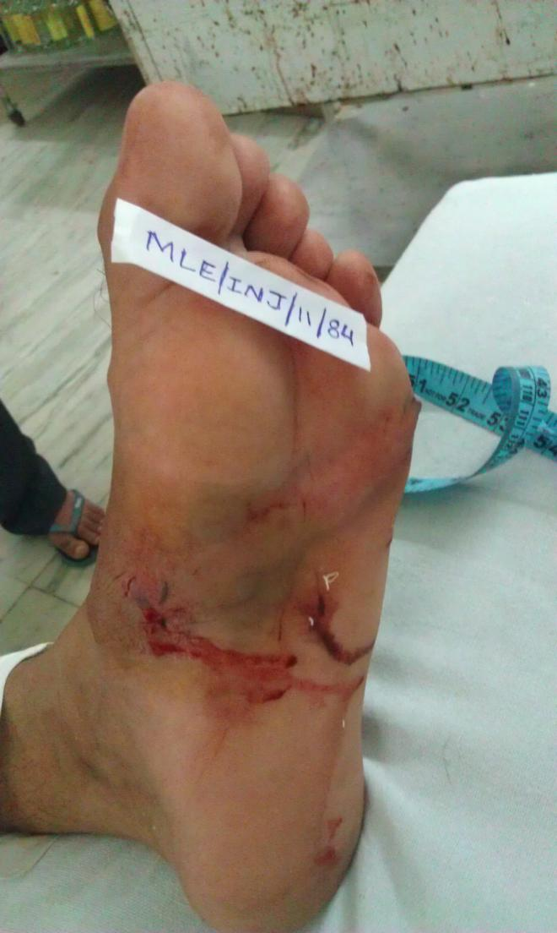
Fig. 1c
The area of sole connecting the wounds was raised tender palpable with prominent bluish margins on both sides indicating the track of wound in the underneath tissues of sole (fig-1c)

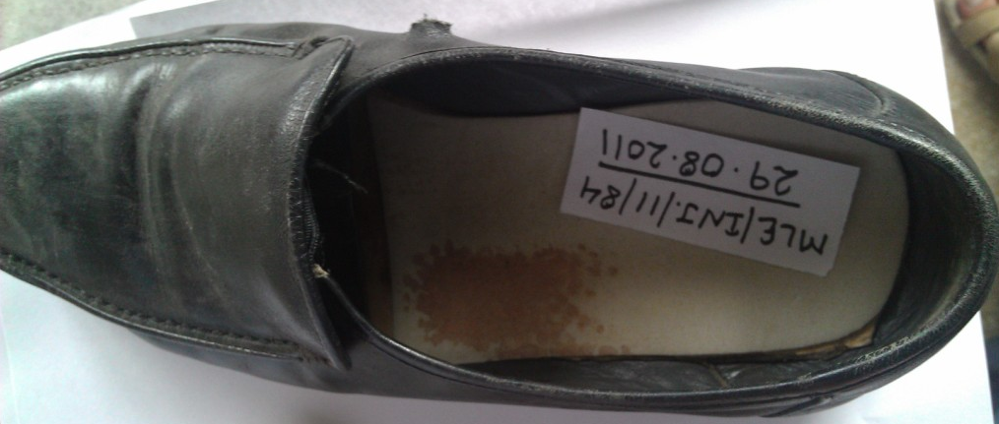
Fig.2

The inner aspect of upper was showing a hole with fibers positioning outwards. The dry blood like stains present on outer middle aspect of inside sole region corresponding to the site of exit wound (fig-2)

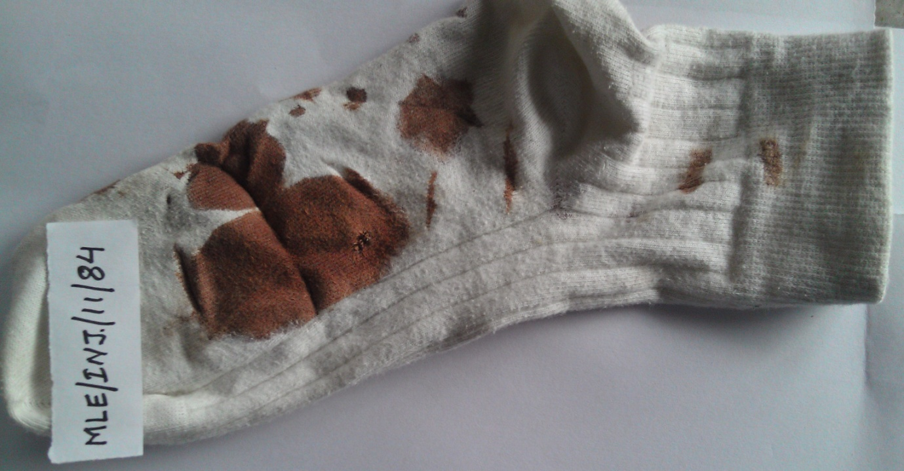
Fig.-3a

The left sock having a hole in the inner aspect of sole area with dry blood like stains indicates the corresponding entry wound (fig-3a)

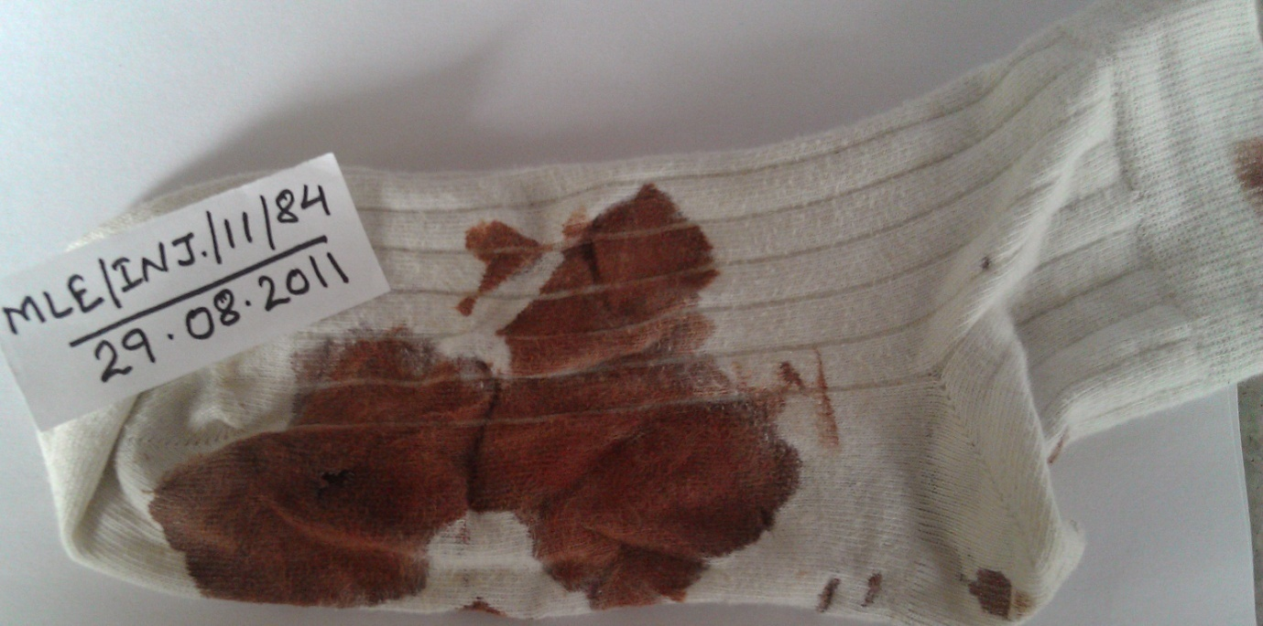
Fig.-3b

The same sock having a hole in the outer aspect of sole area with more blood like stains (compare with fig-3a) indicates the corresponding exit wound (fig-3b)

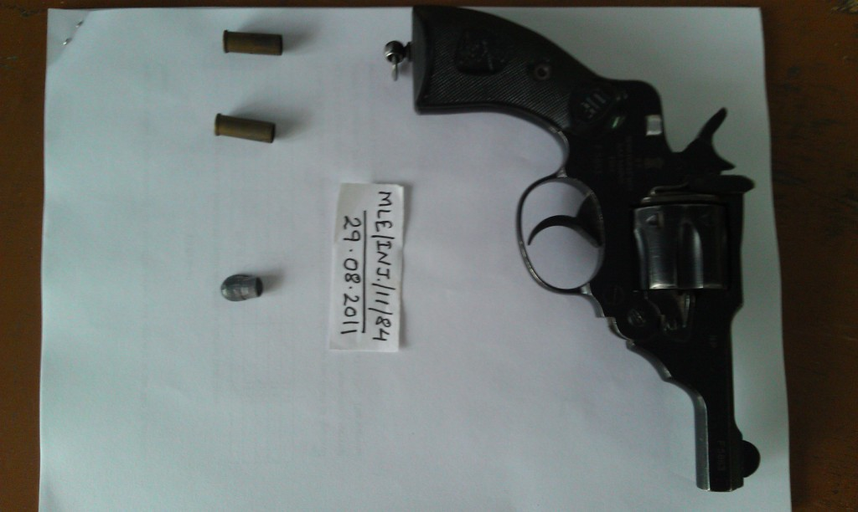
Fig.4

The revolver alleged to have been used by the assailant along with deformed bullet and used cartridges recovered from the scene of crime (fig-4)

